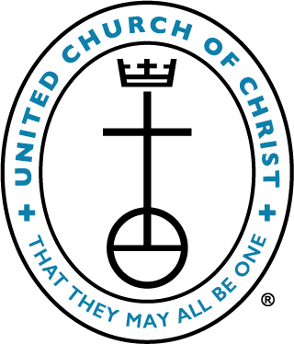
APPLICATION FOR MARRIAGE

ST. PAUL'S UNITED CHURCH OF CHRIST

5 West Arch St., Fleetwood, PA 19522
610-944-0406

Click the “download” icon to save this file to your computer. Fill out the application in your word processing program, save and email to churchofficestpaulsfleetwood@gmail.com. (If you are using a Mac, please save as a Microsoft Word file.) If you prefer using a pen, click the “download” icon, choose “Open with preview” and print the form.

Today’s Date:

Contact Information
Partner A Name:
Age:
Street Address:
Email:
Preferred Telephone:

Partner B Name:
Age:
Street Address:
Email:
Preferred Telephone:

Future Address:
Future Home Phone:

Wedding Service Information
Rehearsal Preferred Date:
Rehearsal Time:
Wedding Preferred Date:
Wedding Time:
Estimated number of wedding guests (may differ from reception total):
Other special requests or preferences:

The schedule of fees is on page 3.

Officiant Information
Pastor Requested: Pastor John Folk
Guest Celebrant’s Name:
Guest Celebrant’s Telephone:
Guest Celebrant’s Email:

Guest Clergy Policy
Only the pastor(s) of St. Paul’s UCC conducts weddings held at St. Paul’s UCC. However, guest clergy are welcome to participate in the service. In consultation with the pastor(s), guest clergy will be expected to use the wedding service designed by the pastor as agreed to by the bride and groom.

Wedding Coordinator
St. Paul’s has a wedding coordinator who will be on site for both the rehearsal and the day of the wedding to assist with details and help your wedding go as smoothly as possible.

No alcoholic beverages or smoking are permitted on the church property.

YOUR WEDDING DATE WILL NOT APPEAR ON OUR CHURCH CALENDAR UNTIL THIS COMPLETED APPLICATION IS RETURNED TO THE CHURCH OFFICE!

Office use only

Date Application returned:

Rec’d by:

Wedding Fees
St. Paul’s U.C.C., Fleetwood

Church Members
Building Use No Fee
Social Room No Fee; Donation up to $100 customary if hosting reception
Clergy Honorarium is allowed but not expected
Organist* $250 Wedding only
$300 Rehearsal and wedding
Wedding Director* $150
Sexton* $75 - $100

Non-Members
Building Use $300
Social Room $300
Clergy Honorarium of $300 is customary
Organist* $300 Wedding only
$350 Rehearsal and wedding
Wedding Director* $150
Sexton* $75 - $100
Bulletin Printing $20 - $100

*Payment of fees for the organist, wedding director, and sexton are due 2 weeks prior to the wedding date.

No alcoholic beverages or smoking are permitted on the church property.

Revised Nov. 2022

